**COURSE MAP:**

**Lesson 0 - Introduction**

**Lesson 1 - Use of functions**

**Lesson 2 - Use of classes**

**Lesson 3 - Making classes**

**Lesson 1**

Using this code we will be able to open a website through python:

webbrowser.open(“http://www.google.com”)

Documentation: <https://docs.python.org/2/library/webbrowser.html>

import time

import webbrowser

Rename file:

os.rename()

<https://docs.python.org/2/library/os.html>

Translatefunction:

<https://stackoverflow.com/questions/41708770/translate-function-in-python-3>

Documentation for the module os:

<https://docs.python.org/2/library/os.html>

**Lesson 3**

You can think of the class as of a blueprint of the buidling. It has different pieces of information about the building e.g number of rooms, type. Using this blueprint we can build different types of buildings e.g office building, apartment building.

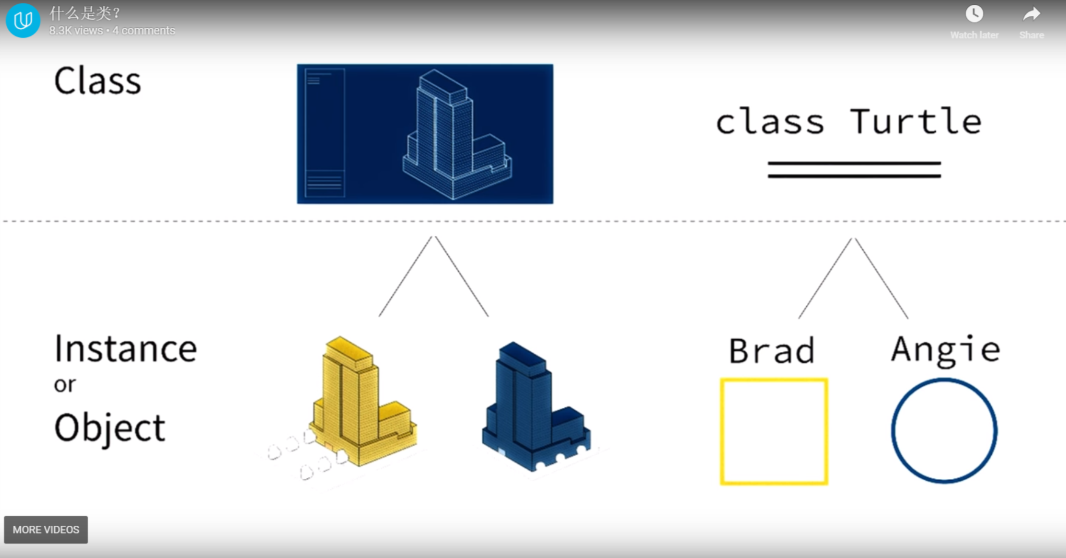

Lesson 5:

Build in python functions:

https://docs.python.org/2/library/functions.html

Urllib is a module in python and def urlopen is a function inside it.

Documentation:

<https://docs.python.org/2/library/urllib.html>

Google style guide for python:

<https://google.github.io/styleguide/pyguide.html>

Lesson 6:

**Lesson 7:**

Class variables -